Normal distribution using Minitab-Lab 8 Name_____________________

- Finding an area (proportion, probability) given a value of the variable.
Assume the cholesterol levels of adult American women can be described by a normal model with mean 188 mg/dL and standard deviation 24 mg/dL

To produce a picture of the cholesterol levels in Minitab select Graph > Probability Distribution Plot… and select View Single and click OK

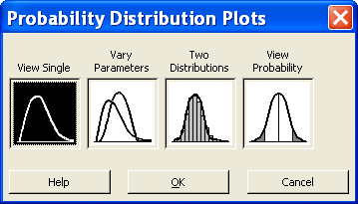

Fill in the dialog boxes as shown below.

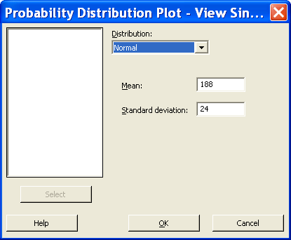

Click OK to produce the graph below.

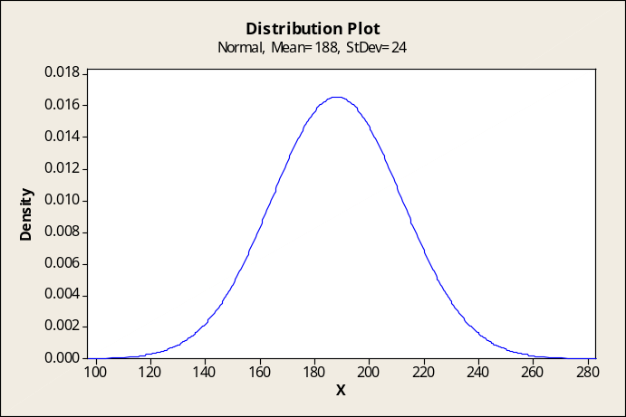

Option 1: Use CALC > Probability Distributions > Normal to calculate the percent of adult American women that you expect to have cholesterol level under 200 (a healthy level).

Input the information (mean and standard deviation) and ask for the cumulative probability (or area from the value 200).
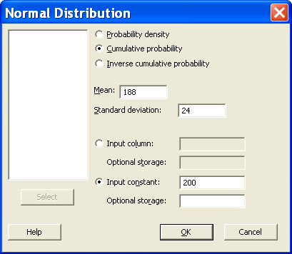

What percent of women have a cholesterol level over 200? ___________

What percent of women have a cholesterol level between 200 and 240 (the previous threshold between healthy and unhealthy levels)? _______________

Option 2: Use Graph > Probability Distribution Plot… and select View Probability

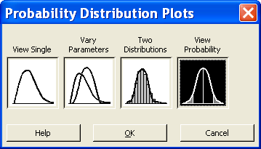

Click OK and fill in the dialog boxes as shown below.

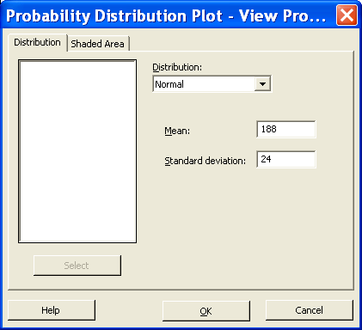

Select Shaded Area > Left Tail (to get the percent of cholesterol levels under 200) and fill in the dialog boxes
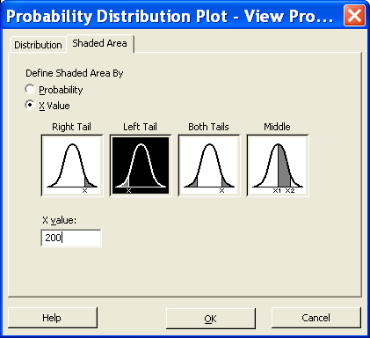

Use Right Tail to get the percent of cholesterol levels above 200. Use Middle to get the percent of cholesterol levels between 200 and 240.

- Finding a value given a proportion

Above what value are the highest 15% of women’s cholesterol levels? MINITAB, same as the normal tables, gives the area under the curve from the beginning up to a certain point.

Option 1: Find the value that separates the lower 85% from the upper 15%, by using the option Inverse cumulative probability

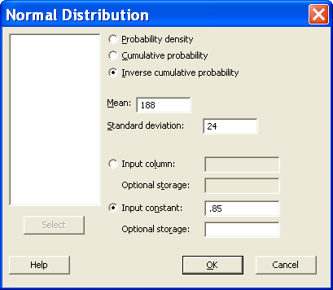

Above what value are the highest 15% of women’s cholesterol levels? __________

What is the lower quartile of the cholesterol levels of adult American women? _________

Option 2: Use Graph > Probability Distribution Plot… and select View Probability > Shaded Area > Probability > Right Tail as shown below

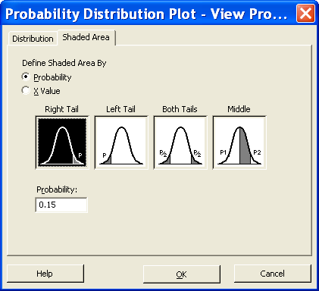

- Generating normal data

In simulation studies is useful to generate synthetic data given a distribution. For example if you want to create a fictional data set of cholesterol levels of 1000 adult American women assuming the mean is 188 and the standard deviation 24 proceed as follows:
Create a new worksheet with FILE>New and selecting the option worksheet
CALC> Random data>normal and input the necessary information

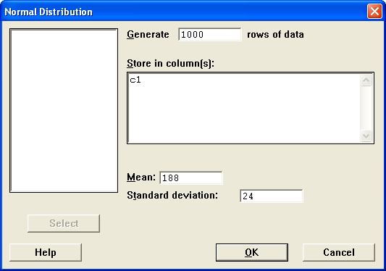

After you have the synthetic data in column C1, obtain a histogram and a normal probability plot. Do not be surprised that your graphs do not look exactly equal if you perform the experience again, these are randomly generated data and each generated batch can differ a bit from the rest.

Repeat the experience but now generate only 20 observations. Observe how difficult it is to recognize through the histogram if the data come from a normal distribution when the data set is small.

- Assume that adults have IQ scores that are normally distributed with a mean of 100 and a standard deviation of 15.
  - Find the probability that a randomly selected individual has an IQ less than 125. That is, find P(x < 125).
  - Find the IQ score which separates the bottom 80% of the adults from the top 20%.

- A firm that manufactures grape juice has a machine that automatically fills bottles. The mean of the process is assumed to be the machine’s setting. The process variation (standard deviation) is 1.2 oz. (Assume that the process has a normal distribution.)
  - Customers get unhappy if the actual level is less than 36 oz but do not mind if it is greater than 36 oz. If you set the machine at 37 oz. what % of the time would the bottle contain less than 36 oz.?
  - The bottle will actually hold 40 oz. If you set the machine to 38, what percent of the time will the bottles overflow?
  - With the machine set at 38 oz., how big would the bottle have to be not to overflow 99.95% of the time?

